Mongodb Assignment Day1

Inserting data to movies collection
use mongo_practice
db.movies.insertMany([
{title: 'Fight Club',writer: 'Chuck Palahniuko',year: 1999,actors:['Brad Pitt,Edward Norton']},
{title: 'Pulp Fiction',writer:'Quentin Tarantino',year: 1994,actors: ['John Travolta',Uma Thurman']},
{title:'Inglorious Basterds',writer:'Quentin Tarantino,year:2009,actors:['Brad Pitt','Diane Kruger','Eli Roth']},
{title:'The Hobbit An Unexpected Journey',writer: 'J R R Tolkein',year:2012,franchise: 'The Hobbit'},
])
db.movies.insertMany([
{title:'The Hobbit The Desolation of Smaug',writer: J R R Tolkein,year:2013,franchise: 'The Hobbit'},
{title:'The Hobbit The Battle of the Five Armies',writer:'J R R Tolkein',year:2012,franchise:'The Hobbit',
synopsis: 'Bilbo and company are forced to engage in a war against an array of combatants and keep
the lonely Mountain from falling into the hands of a rising darkness'},
{title: 'Pee We Hermans Big Adventure'},
{title: 'Avatar'}
])

Find querys
Q1
db.movies.find().pretty()
Q2
db.movies.find({writer:”Quentin Tarantino”).pretty
Q3
db.movies.find({actors:”Brad pitt”}).pretty()
Q4
db.movies.find({franchise:“Hobbit”}).pretty()
Q5
db.movies.find({year:{$and;[{$gte:1990,$lte:1999}]}}).pretty()
Q6
db.movies.find({year:{$and:[{$gt:2010,$lt:2000}]}}).pretty()

Update commands
db.movies.update({title: 'The Hobbit The Desolation of Smaug'},{$set: {synopsis: 'The dwarves,along with Bilbo Baggins and Gandalf the Grey continue their quest to reclaim Erebor their homeland from Smaug Bilbo Baggins is in possesion of a mysterious and magical ring'}})
WriteResult({ "nMatched" : 1, "nUpserted" : 0, "nModified" : 1 })

MongoDB Enterprise atlas-blsyrp-shard-0:PRIMARY> db.movies.findOneAndUpdate({title: 'Pulp Fiction'},{$set: {actors: ['John Travolta','Uma Thurman','Samuel L Jackson']}})
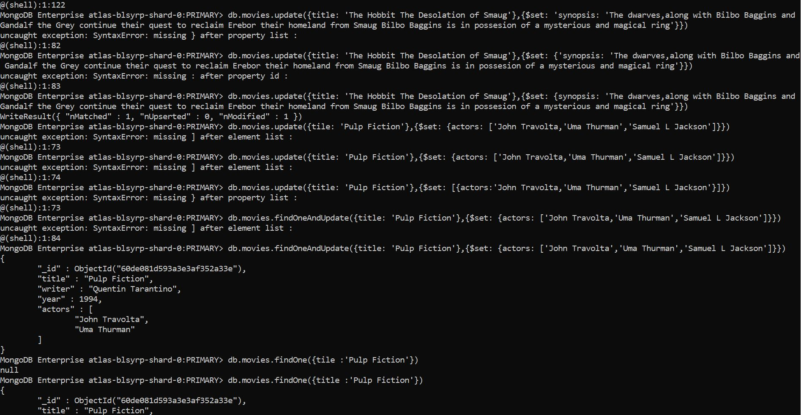
Text search
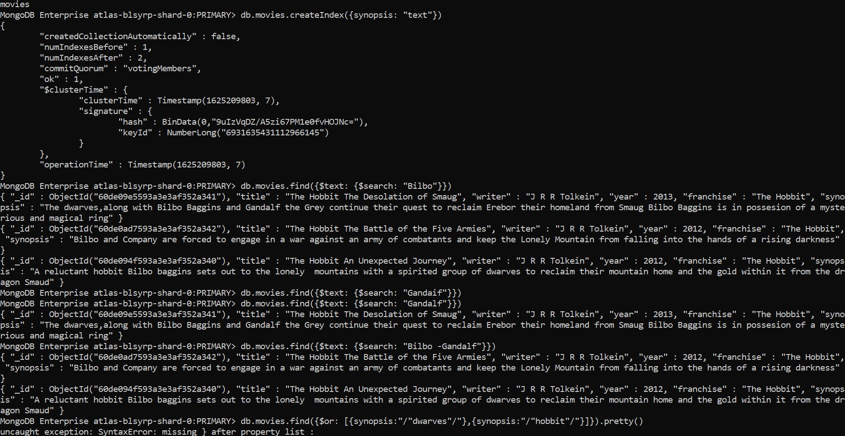

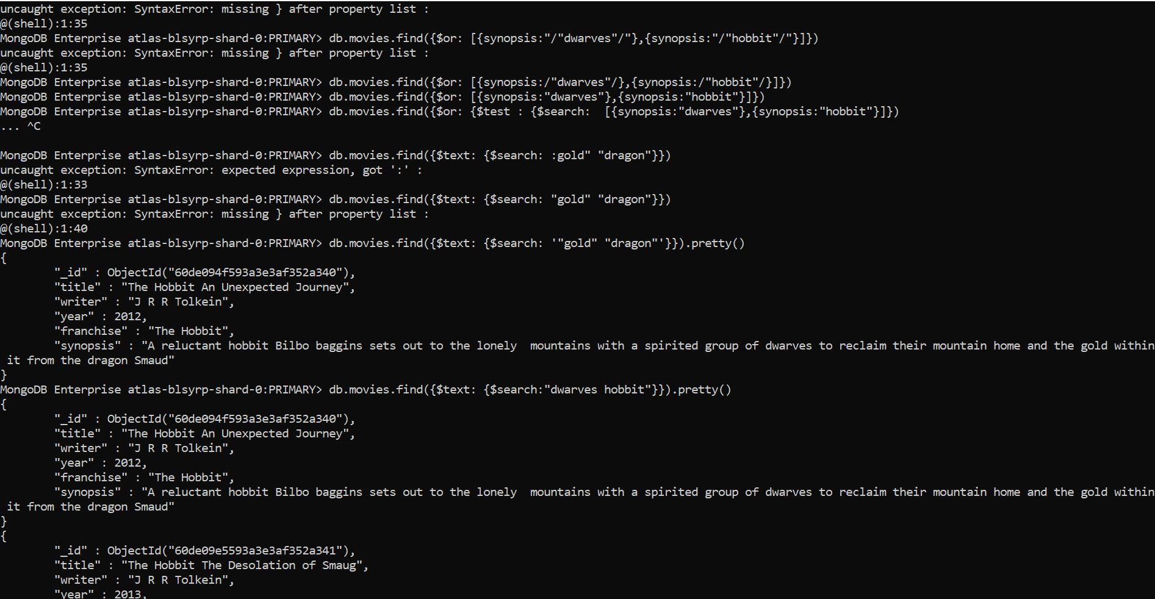
Deleting and Relationship
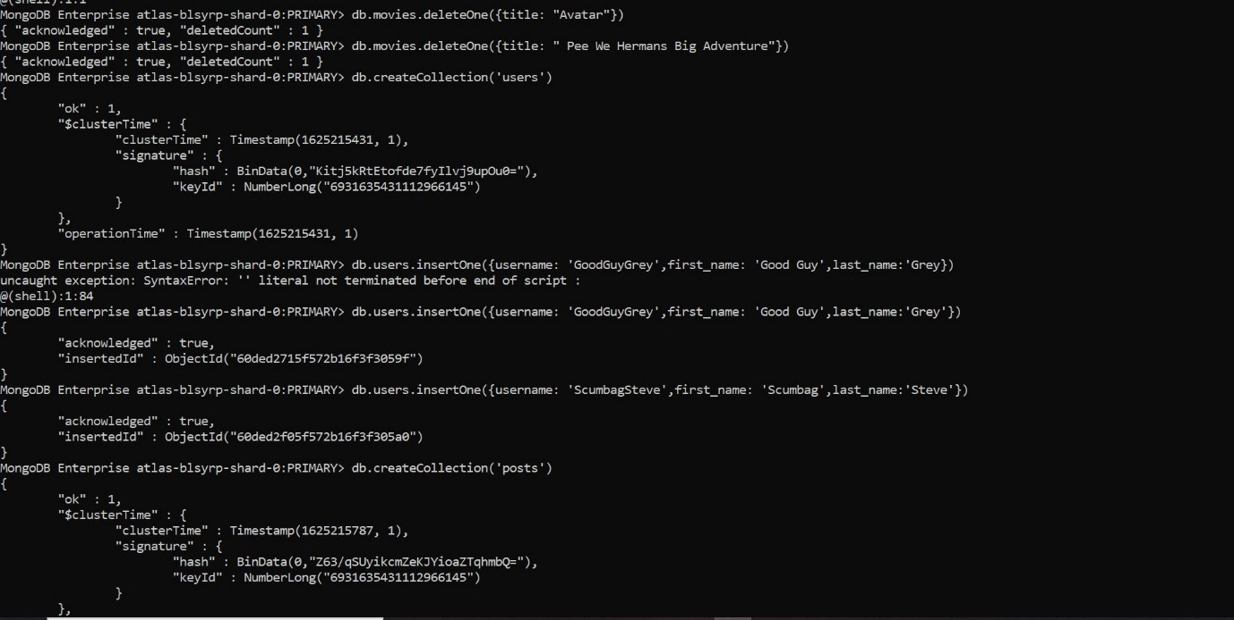
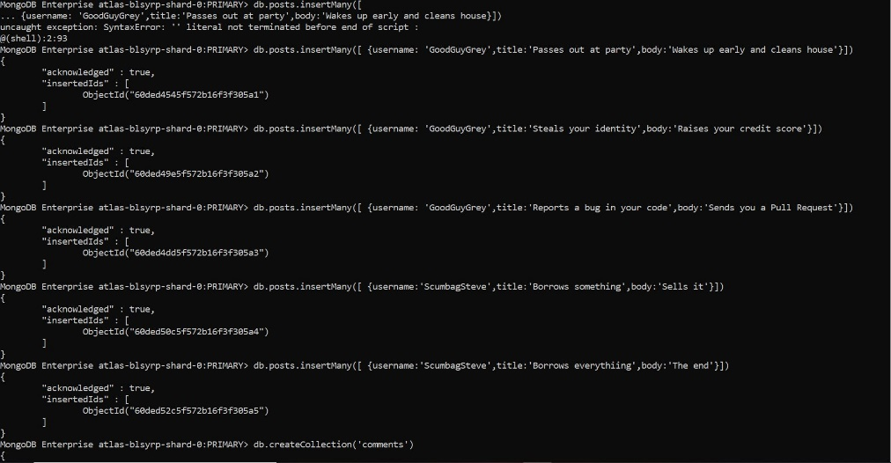
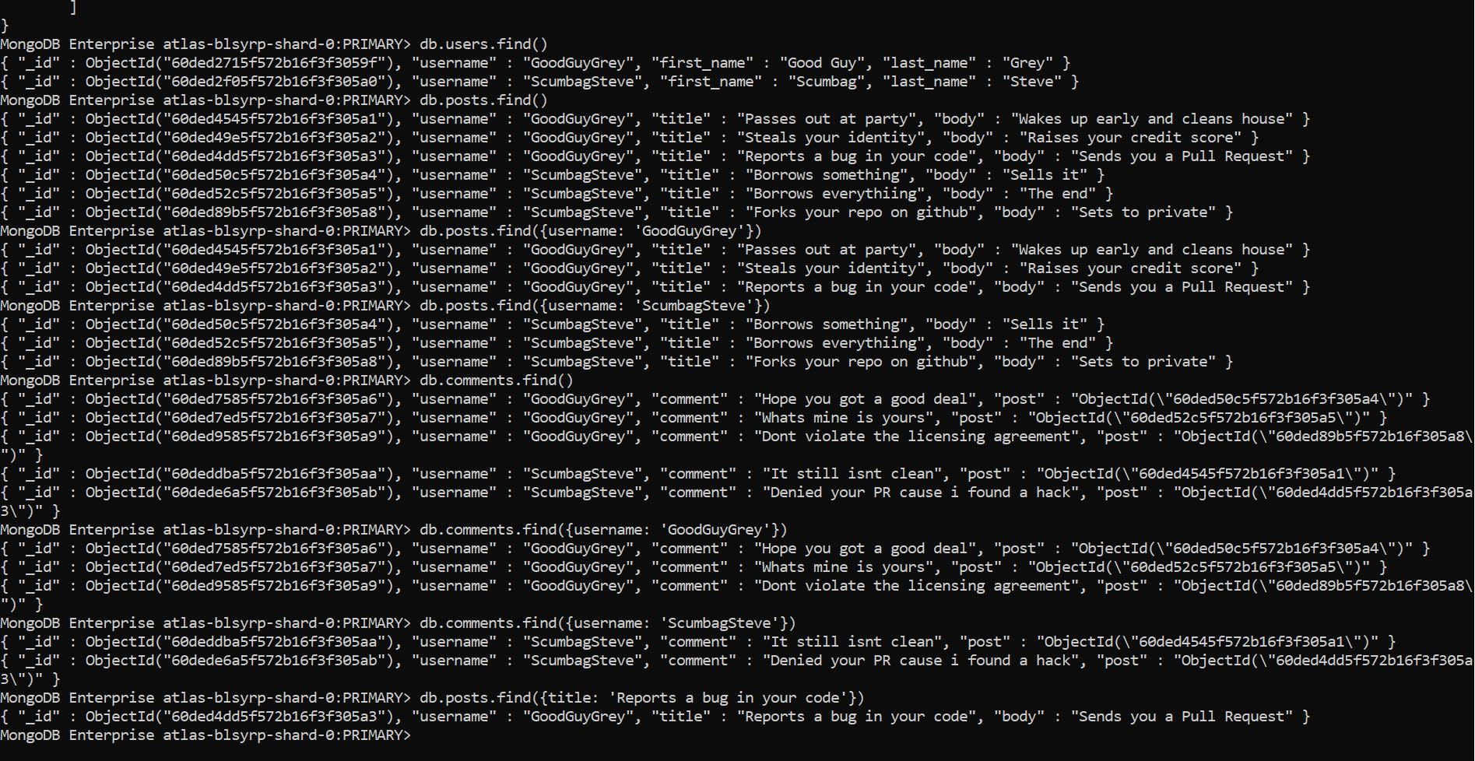

DAY 2 Assignment
Using find
1 db.zipcodes.find({$and: [{city: "ATLANTA"},{state:"GA"}]})
Matching zipcodes
2 db.zipcodes.aggregate([{$match:{city :'ATLANTA',state:'GA'}}])
Grouping city to count zipcodes in altlanta
3 db.zipcodes.aggregate([{$match:{"city": "ATLANTA"}},{$group: {_id: "$city",count: {$sum : 1}}}])
Population in Atlanta
4 db.zipcodes.aggregate([{$match:{"city": "ATLANTA"}},{$group: {_id: "$city",total: {$sum : "$pop"}}}])
Question 2
Population by state
5 db.zipcodes.aggregate([{$group: {_id: "$state",total: {$sum: "$pop"}}} ])
Sorting from highest to lowest
6 db.zipcodes.aggregate([{$group: {_id: "$state",total: {$sum: "$pop"}}},{$sort:{total: -1}} ])
Limiting to 3
7 db.zipcodes.aggregate([{$group: {_id: "$state",total: {$sum: "$pop"}}},{$sort:{total: -1}},{$limit:3} ])

Total population of each city by combination of city and state
8 db.zipcodes.aggregate([{$group: {_id: {city: "$city",state: "$state",total: {$sum: "$pop"}}}} ])
Sorting in the combination
9 db.zipcodes.aggregate([{$group: {_id: {city: "$city",state: "$state",total: {$sum: "$pop"}}}},{$sort: {"_id.total": -1}} ])
Limiting to top threee
10 db.zipcodes.aggregate([{$group: {_id: {city: "$city",state: "$state",total: {$sum: "$pop"}}}},{$sort: {"_id.total": -1}},{$limit:3} ])
Top 3 cities in population in texas
11 db.zipcodes.aggregate([{$match:{state:"TX"}},{$group: {_id: {city: "$city",state: "$state",total: {$sum: "$pop"}}}},{$sort: {"_id.total": -1}},{$limit:3} ])

Bonus
To find average of population in states
12 db.zipcodes.aggregate([{$group: {_id: "$state",avgpopulation: {$avg :"$pop"}}}])
Top 3 states in terms of population
13 db.zipcodes.aggregate([{$group: {_id: "$state",avgpopulation: {$avg :"$pop"}}},{$sort: {avgpopulation: -1}},{$limit:3}])

DAY 3 Assignment
Displaying databases
show dbs
admin 0.000GB
first-test 0.000GB
local 3.327GB
mongo_practice 0.000GB
population 0.002GB
restaurants 0.001GB
sampledatabase 0.000GB

use restaurants
Q1
db.addresses.find().pretty()
Q2
db.addresses.aggregate([
... {$project: {restaurant_id:1,name:1,borough:1,cuisine:1}}])
Q3
db.addresses.aggregate([ {$project: {restaurant_id:1,name:1,borough:1,cuisine:1,_id:0}}])
Q4
db.addresses.aggregate([ {$project: {restaurant_id:1,name:1,borough:1,"address.zipcode":1,_id:0}}])
Q5
db.addresses.aggregate([{$match: {borough:"Bronx"}},{$limit:5}])
Q6
db.addresses.aggregate([{$match: {borough:"Bronx"}}])
Q7
db.addresses.aggregate([{$match: {borough:"Bronx"}},{$skip : 5},{$limit:5}])
Q8
db.addresses.aggregate([{$match:{"grades.score":{$gt:90}}}]).pretty()
db.addresses.find({grades:{$elemMatch:{score:{$gt:90}}}})
Q9
db.addresses.find({grades:{$elemMatch:{score:{$gt:80,$lt:100}}}})
Q10
db.addresses.find({"address.coord.0":{$lt:-95.754168}}).pretty()
Q11
db.addresses.find({$and:[{cuisine:{$ne:"American"}},{"grades.score":{$gt:70}},{"address.coord.0":{$lt:-65.754168}}])
Q12
db.addresses.find({$and:[{cuisine:{$ne:"American"}},{"grades.score":{$gt:70}},{"address.coord.1":{$lt:-65.754168}}]})
Q13
db.addresses.aggregate([{$match:{$and:[{cuisine:{$ne:"American"}},{borough:{$ne:"Brooklyn"}},{"grades.grade":"A"}]}},{$sort:{cuisine:-1}}])
Q14
db.addresses.find({name:{$regex:/^Wil/}},{restaurant_id:1,name:1,cuisine:1,borough:1})
Q15
db.addresses.find({name:{$regex:/ces$/}},{restaurant_id:1,name:1,cuisine:1,borough:1}).pretty()
Q16
db.addresses.find({name:{$regex:/Reg/}},{restaurant_id:1,name:1,cuisine:1,borough:1}).pretty()
Q17
db.addresses.find({$and:[{borough:"Bronx"},{$or:[{cuisine:"American"},{cuisine:"Chinese"}]}]}).pretty()
Q18
db.addresses.find({$or:[{borough:"Staten Island"},{borough:"Queens"},{borough:"Bronx"},{borough:"Brooklyn"}]},{restaurant_id:1,name:1,borough:1,cuisine:1}).pretty()
Q19
db.addresses.find({$nor:[{borough:"Staten Island"},{borough:"Queens"},{borough:"Bronx"},{borough:"Brooklyn"}]},{restaurant_id:1,name:1,borough:1,cuisine:1}).pretty()
Q20
db.addresses.aggregate([{$match:{"grades.score":{$lte:10}}},{$project:{restaurant_id:1,name:1,borough:1,cuisine:1}}])
Q21
db.addresses.aggregate([{$match:{$or:[{name:/^Wil/},{$and:[{cuisine:{$not:/American/}},{cuisine:{$not:/Chinese/}}]}]}},{$project:{name:1,borough:1,cuisine:1,restaurant_id:1}}])
Q22
db.addresses.aggregate([{$unwind:"$grades"},{$match:{$and:[{"grades.grade":"A"},{"grades.score":11},{"grades.date":ISODate("2014-08-11T00:00:00Z")}]}},{$project:{name:1,restaurant_id:1,grades:1}}])
Q23
db.addresses.aggregate([{$match:{$and:[{"grades.grade":"A"},{"grades.1.score":9},{"grades.1.date":ISODate("2014-08-11T00:00:00Z")}]}},{$project:{name:1,restaurant_id:1,grades:1}}])
Q24
db.addresses.aggregate([{$match:{"address.coord.1":{$gt:42,$lte:52}}},{$project:{name:1,borough:1,"address.coord":1,restaurant_id:1}}])
Q25
db.addresses.aggregate([{$sort:{name:1}}]).pretty()
Q26
db.addresses.aggregate([{$sort:{name:-1}}]).pretty()
Q27
db.addresses.aggregate([{$sort:{cuisine:-1,borough:1}}])
Q28
db.addresses.aggregate([{$match:{"address.street":{$exists:false}}}])
Q29
db.addresses.find({"address.coord":{$type:"double"}})
Q30
db.addresses.find({"grades.score":{$mod:[7,0]}},{restaurants_id:1,name:1,grades:1})
Q31
db.addresses.find({name:{$regex:/mon/}},{name:1,borough:1,"address.coord":1,cuisine:1,_id:0})
Q32
db.addresses.find({name:{$regex:/^Mad/}},{name:1,borough:1,"address.coord":1,cuisine:1,_id:0})

